

**Course Information**

Course Title: Digital Image Processing

Section: 2

Course Instructor: Dr. Ahmed Wasif Reza

Associate Professor

Department of Computer Science & Engineering

**Lab-05**

**Student’s Information**

**Name:** Aahadul Islam Fardin

**ID:** 2019-1-60-224

**Department:** Computer Science & Engineering

**Date of Submission: 16 April 2023**

1. Apply Gaussian noise to Figure 1, and then use the following to restore the image:

Geometric Mean filter

%% i. Geometric Mean filter

img = imread('Picture1.png');

j = imnoise(img, "gaussian");

I = rgb2gray(j);

I = im2double(I);

n = 3;

F = exp(imfilter(log(I), ones(n, n), 'replicate')).^(1/(n*n));

subplot(2, 3, 1), imshow(img), title('Original Image');

subplot(2, 3, 2), imshow(j), title('After apply noise');

subplot(2, 3, 3), imshow(F), title('GMF');

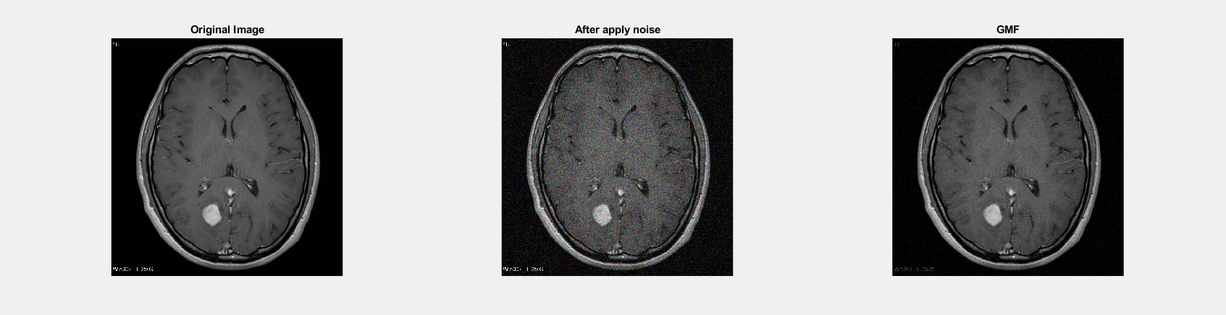

Harmonic Mean filter

%% ii. Harmonic Mean filter

img = imread('Picture1.png');

j = imnoise(img, "gaussian");

I = rgb2gray(j);

I = im2double(I);

n = 3;

SF = (n*n)./imfilter(1./(I+eps), ones(n, n),'replicate');

subplot(2, 3, 1), imshow(img), title('Original Image');

subplot(2, 3, 2), imshow(j), title('After apply gaussian noise');

subplot(2, 3, 3), imshow(SF), title('HMF');

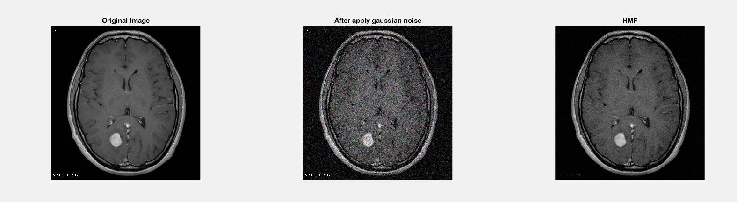

Contra-harmonic Mean filter

%% iii. Contra-harmonic Mean filter

img = imread('Picture1.png');

j = imnoise(img, "gaussian");

I = rgb2gray(j);

I = im2double(I);

n = 3;

order = 1;

SF = imfilter(I.^(order+1), ones(n, n),'replicate')./(imfilter(I.^(order), ones(n, n),'replicate')+eps);

subplot(2, 3, 1), imshow(img), title('Original Image');

subplot(2, 3, 2), imshow(j), title('After apply gaussian noise');

subplot(2, 3, 3), imshow(SF), title('CHMF');

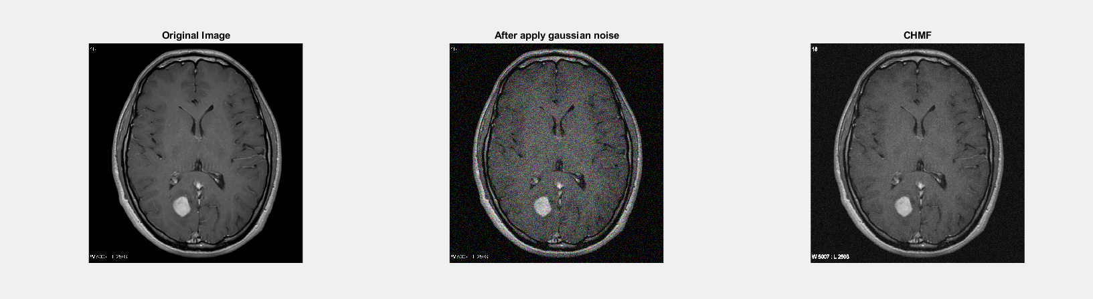

1. Apply Gaussian noise to Figure 1, and then use the following order statistic filters to restore the image:

Median filter

%% i. Median filter

img = imread('Picture1.png');

j = imnoise(img, "gaussian");

I = rgb2gray(j);

I = im2double(I);

B = ordfilt2(I,5,ones(3,3));

subplot(2, 3, 1), imshow(img), title('Original Image');

subplot(2, 3, 2), imshow(j), title('After apply gaussian noise');

subplot(2, 3, 3), imshow(B), title('Median Filter');

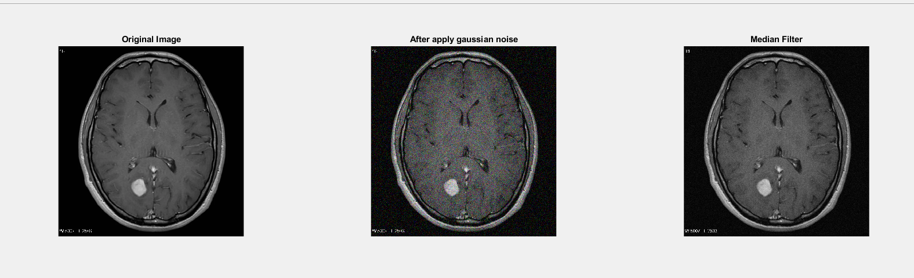

Maximum filter

%% ii. Maximum filter

img = imread('Picture1.png');

j = imnoise(img, "gaussian");

I = rgb2gray(j);

I = im2double(I);

B = ordfilt2(I,9,ones(3,3));

subplot(2, 3, 1), imshow(img), title('Original Image');

subplot(2, 3, 2), imshow(j), title('After apply gaussian noise');

subplot(2, 3, 3), imshow(B), title('Maximum Filter');

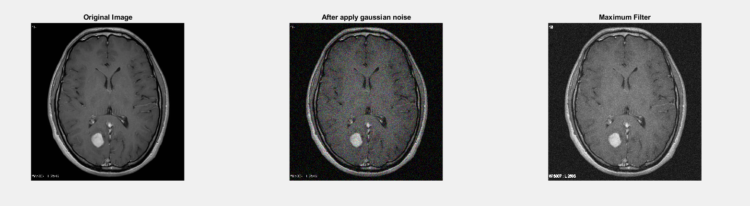

Minimum filter

%% iii. Minimum filter

img = imread('Picture1.png');

j = imnoise(img, "gaussian");

I = rgb2gray(j);

I = im2double(I);

B = ordfilt2(I,1,ones(3,3));

subplot(2, 3, 1), imshow(img), title('Original Image');

subplot(2, 3, 2), imshow(j), title('After apply gaussian noise');

subplot(2, 3, 3), imshow(B), title('Minimum Filter');

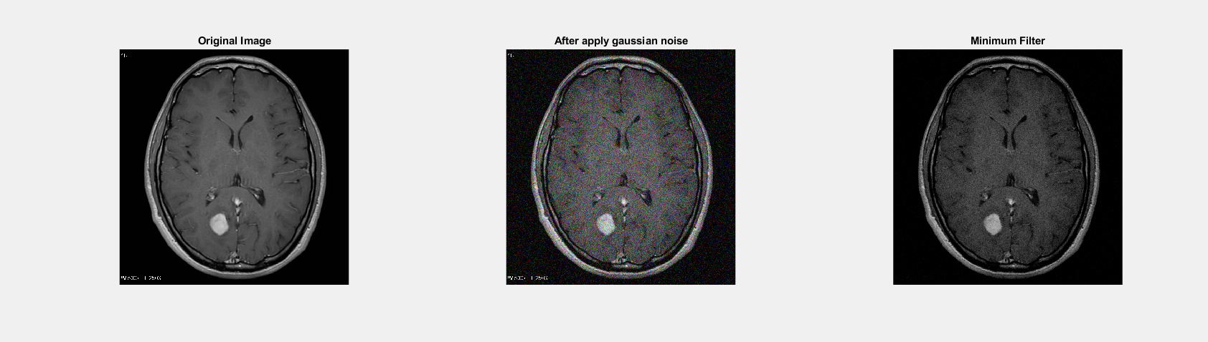

Midpoint filter

%% iv. Midpoint filter

img = imread('Picture1.png');

j = imnoise(img, "gaussian");

I = rgb2gray(j);

I = im2double(I);

min = ordfilt2(I,1,ones(3,3));

max = ordfilt2(I,9,ones(3,3));

B = imlincomb(0.5,min,0.5,max);

midpointimage = B;

subplot(2, 3, 1), imshow(img), title('Original Image');

subplot(2, 3, 2), imshow(j), title('After apply gaussian noise');

subplot(2, 3, 3), imshow(B), title('Midpoint Filter');

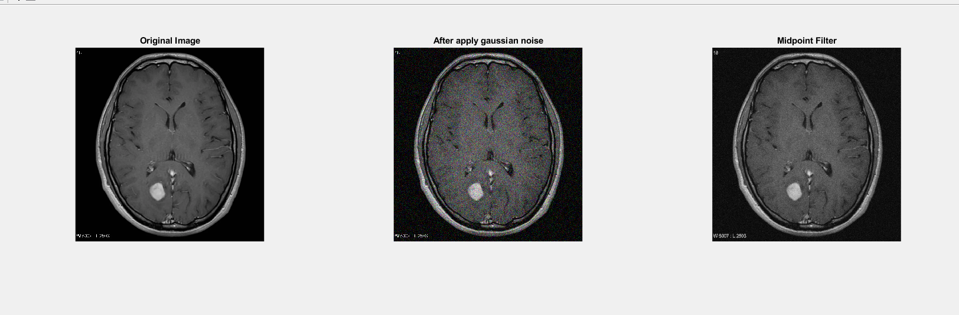

Alpha-trimmed filter

%% v. Alpha-trimmed filter

img = imread('Picture1.png');

j = imnoise(img, "gaussian");

I = rgb2gray(j);

I = im2double(I);

n = 3;

d = 2;

w = ones(n, n)/((n*n)-d);

B = imfilter(I, w,'replicate', 'same');

subplot(2, 3, 1), imshow(img), title('Original Image');

subplot(2, 3, 2), imshow(j), title('After apply gaussian noise');

subplot(2, 3, 3), imshow(B), title('Alpha-trimmed Filter');

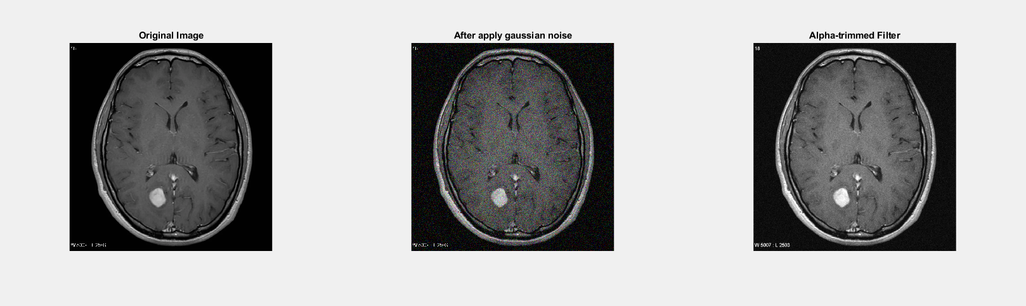

Trimmed filter

%% vi. Trimmed mean filter

img = imread('Picture1.png');

j = imnoise(img, "gaussian");

I = rgb2gray(j);

I = im2double(I);

n = 3;

w = ones(n, n)/(n*n);

SF = imfilter(I, w, 'replicate')+eps;

subplot(2, 2, 1), imshow(img), title('Original Image');

subplot(2, 2, 2), imshow(j), title('After apply gaussian noise');

subplot(2, 2, 3), imshow(SF), title('TMF');

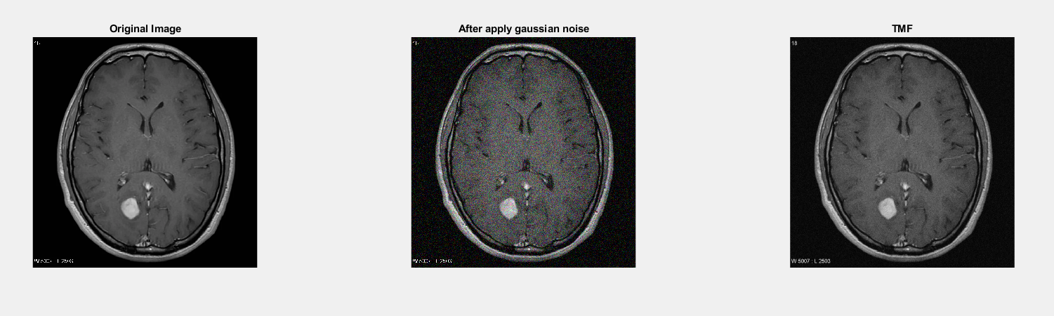

1. By observing and comparing each of the outputs, determine which filter restores the image closest to its original state. Mention the reasoning behind your observation and choose the most suitable image for the following problems.

Alfa trimmed filter and contra harmonic mean filter working well

1. Detect the tumor from the image from Problem 3 using the segmentation approaches listed below:

(***Outline the segmented object to highlight the tumor****. You can crop the image for accurate segmentation.*)

* + 1. Similarity approaches:

Local/Regional Thresholding

I = midpointimage;

T = graythresh(I);

a = im2bw(I, T);

subplot(2, 2, 1), imshow(I), title('Image from problem 3');

subplot(2, 2, 2), imshow(a), title('Local/Regional Thresholding');

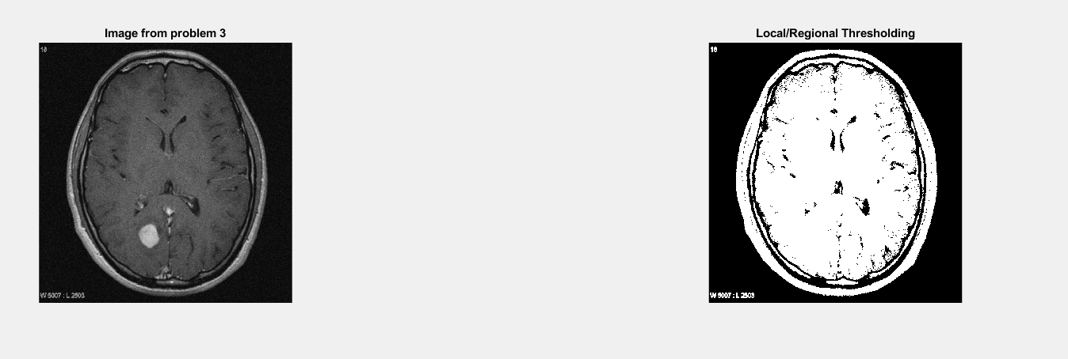

Global Thresholding

%% b) Global Thresholding

I = midpointimage;

BW = imbinarize(I,'global');

subplot(1,2,1);imshow(img);title('Original Image');

subplot(1,2,2);imshow(BW);title('Global Thresholding');

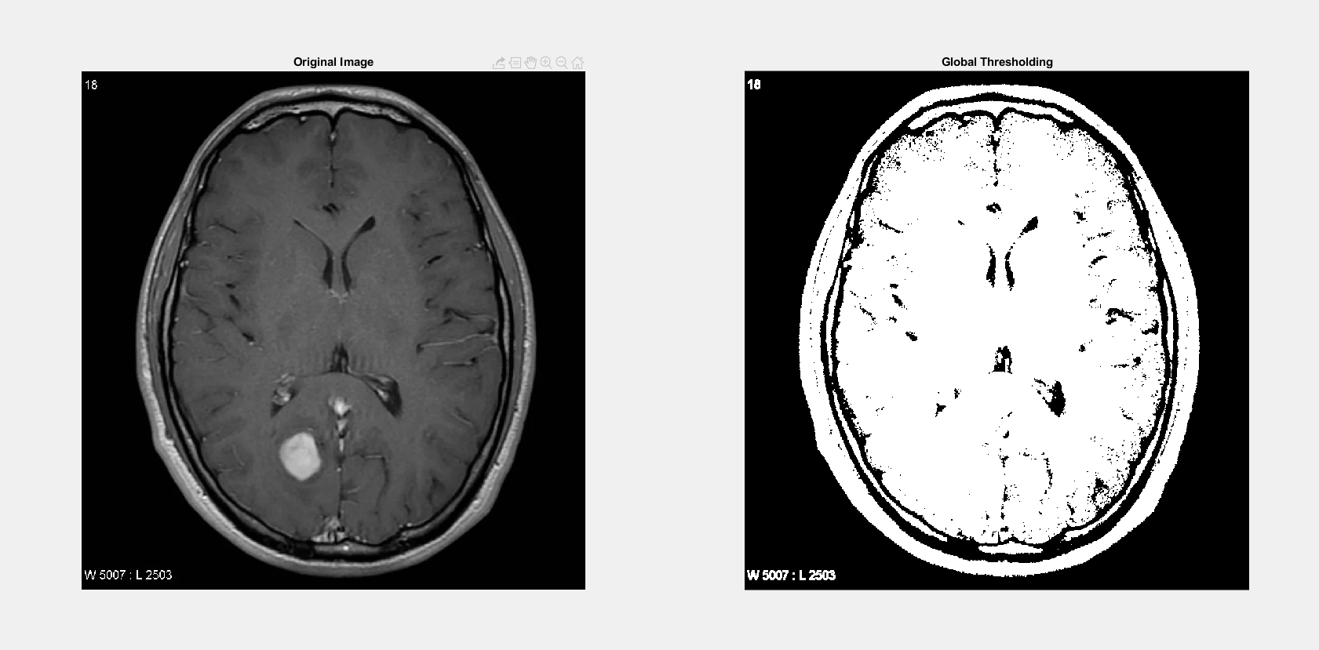

Variable Thresholding

%% c) Variable Thresholding

I = midpointimage;

[r c]=size (I);

output=zeros (r, c);

starts=floor (1:c/10:c);

ends = starts (2:length(starts));

ends=[ends c];

figure, imshow(I);

hold on;

for i = 1:10

plot([ends(i) ends(i)], [1,r], 'w');

end

for i = 1:10

temp = img(:, starts(i):ends(i));

out(:, starts(i):ends(i))=im2bw(temp,graythresh(temp));

plot([ends(i) ends(i)], [1,r], 'w');

end

subplot(2, 2, 1), imshow(I), title('Original Image');

subplot(2, 2, 2), imshow(out), title('Variable Thresholding Image');

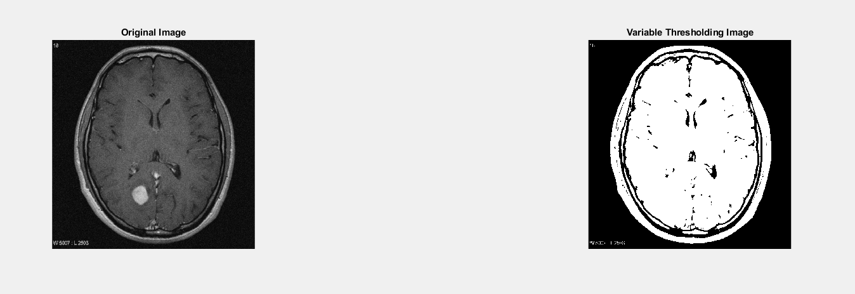

Dynamic/Adaptive Thresholding

%% d) Dynamic/Adaptive Thresholding

I = midpointimage;

BW = imbinarize(I,'adaptive');

subplot(1,2,1);imshow(img);title('Original Image');

subplot(1,2,2);imshow(BW);title('Dynamic/Adaptive Thresholding');

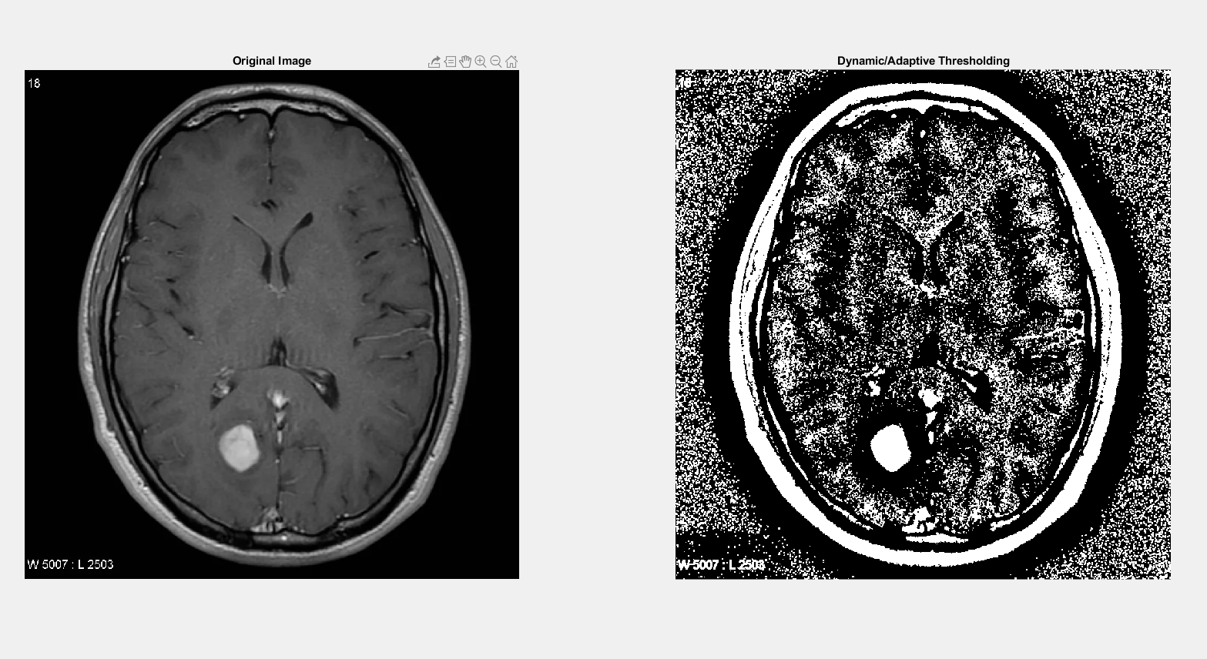

Discontinuity approaches: Edge Detection (Sobel, Canny, Prewitt)

%% a)

img = midpointimage;

sobel = edge(img, 'Sobel');

subplot(1,2,1);imshow(img);title('Original Image');

subplot(1,2,2);imshow(sobel);title('sobel filtered Image');

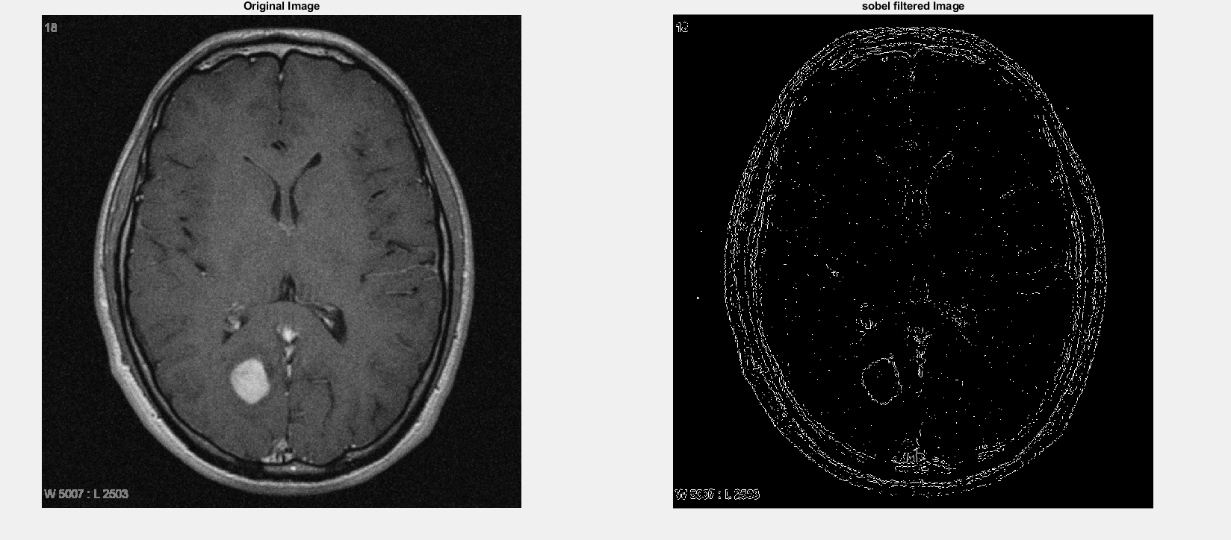

%% b)

img_canny=edge(img, 'Canny');

subplot(2,2,1);imshow(img);title('Origial Image');

subplot(2,2,2);imshow(img_canny);title('Canny Edge');

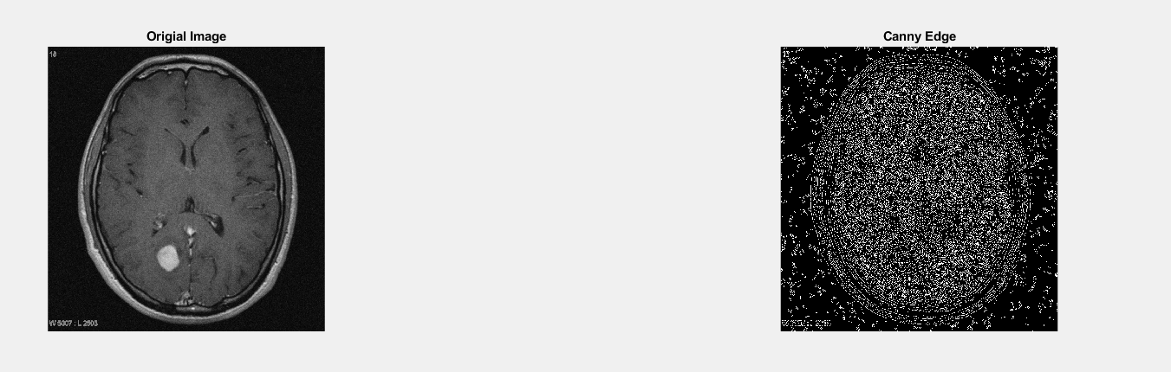

%% c)

prewitt = edge(img, 'Prewitt');

subplot(1,2,1);imshow(img);title('Original Image');

subplot(1,2,2);imshow(prewitt);title('prewitt filtered Image');

